Experiment 1: String Constructors
Problem Statement:
Write a Java program to demonstrate different ways of creating and initializing String objects using various String constructors.
Requirements:
- Create a String using a string literal.
- Create a String using new String().
- Create a String from a character array.
- Create a String from a byte array.
- Display all the created strings.
- Demonstrate the difference between String objects created using literals and new.
public class StringInitDemo {
public static void main(String[] args) {
String s1 = "Java Programming";
String s2 = "Java Programming";
String s3 = new String("Java Programming");
char[] chars = {'O', 'O', 'P', 's'};
String s4 = new String(chars);
byte[] bytes = {67, 79, 68, 69};
String s5 = new String(bytes);
System.out.println("--- String Objects ---");
System.out.println("Literal: " + s1);
System.out.println("New String: " + s3);
System.out.println("From Char Array: " + s4);
System.out.println("From Byte Array: " + s5);
System.out.println("\n--- Memory Reference Comparison (==) ---");
System.out.println("s1 == s2 : " + (s1 == s2)); // true (Same object from String Pool)
System.out.println("s1 == s3 : " + (s1 == s3)); // false (Literal in Pool vs Object in Heap)
System.out.println("\n--- Value Comparison (.equals) ---");
System.out.println("s1.equals(s3) : " + s1.equals(s3)); // true (Same character content)
}
}
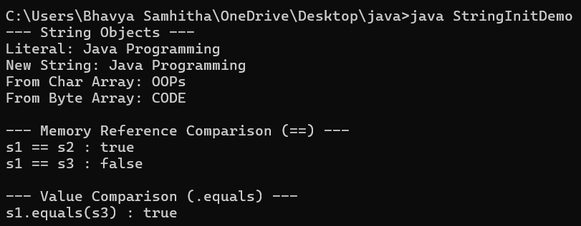

Experiment 2: StringBuffer Class
Problem Statement:
Write a Java program to demonstrate the functionality of the StringBuffer class by performing various mutable string operations.
Requirements:
- Create a StringBuffer object.
- Append text to the buffer.
- Insert text at a specified position.
- Replace a portion of the string.
- Delete characters from the buffer.
- Reverse the contents.
- Display the current length and capacity of the StringBuffer.
public class StringBufferDemo {
public static void main(String[] args) {
// 1. Create a StringBuffer object with initial content
StringBuffer sb = new StringBuffer("Hello");
System.out.println("Initial string: " + sb);
System.out.println("Initial Length: " + sb.length());
System.out.println("Initial Capacity: " + sb.capacity());
System.out.println("----------------------------------------");
sb.append(" World");
System.out.println("After append(\" World\"): " + sb);
sb.insert(5, ",");
System.out.println("After insert(5, \",\"): " + sb);
sb.replace(7, 12, "Java");
System.out.println("After replace(7, 12, \"Java\"): " + sb);
sb.deleteCharAt(5);
System.out.println("After deleteCharAt(5): " + sb);
sb.reverse();
System.out.println("After reverse(): " + sb);
System.out.println("----------------------------------------");
System.out.println("Final String: " + sb);
System.out.println("Final Length: " + sb.length());
System.out.println("Final Capacity: " + sb.capacity());
}
}
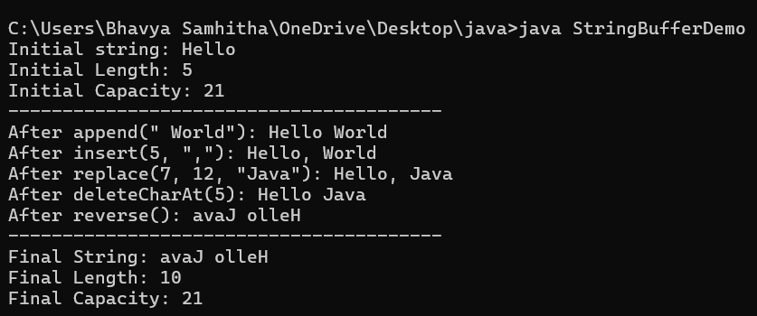

Experiment 3: StringTokenizer Class
Problem Statement:
Write a Java program to tokenize a given sentence using the StringTokenizer class and display each individual token.
Requirements:
- Read a sentence from the user.
- Use StringTokenizer to split the sentence into words.
- Display each token separately.
- Display the total number of tokens.
- Repeat the operation using a user-specified delimiter.
import java.util.Scanner;
import java.util.StringTokenizer;

public class StringTokenizerDemo {
public static void main(String[] args) {
Scanner scanner = new Scanner(System.in);
System.out.print("Enter a sentence: ");
tokenizeAndPrint(scanner.nextLine(), null);
System.out.print("\nEnter a custom delimiter (e.g., , or -): ");
String delimiter = scanner.nextLine();
System.out.print("Enter text using the custom delimiter: ");
tokenizeAndPrint(scanner.nextLine(), delimiter);
scanner.close();
}
private static void tokenizeAndPrint(String text, String delimiter) {
StringTokenizer st = (delimiter == null) ? new StringTokenizer(text) : new StringTokenizer(text, delimiter);
System.out.println("Total tokens: " + st.countTokens());
System.out.println("Tokens:");
while (st.hasMoreTokens()) {
System.out.println("- " + st.nextToken());
}
}
}
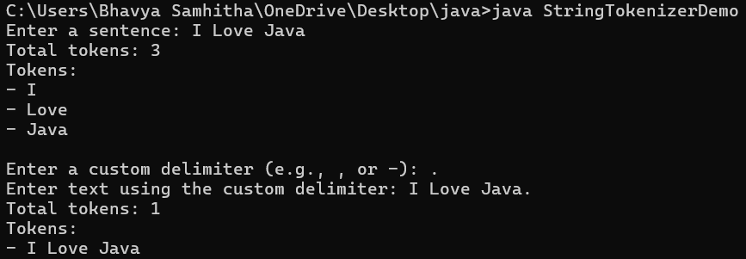

Inheritance

Experiment 4: Basic Inheritance
Problem Statement:
Write a Java program to demonstrate single inheritance by creating a superclass containing common properties and methods and a subclass that inherits and extends the functionality of the superclass.
Requirements:
- Create a superclass Person with attributes such as name and age.
- Define a method to display the person details.
- Create a subclass Student that inherits from Person.
- Add student-specific attributes such as roll number and branch.
- Display all details using the subclass object.
class Person {
String name = "Anirudh";
int age = 20;

void displayPerson() {
System.out.println("Name: " + name);
System.out.println("Age: " + age);
}
}
class Student extends Person {
int rollNo = 101;
String branch = "CSE";

void displayStudent() {
displayPerson(); // Call parent method
System.out.println("Roll No: " + rollNo);
System.out.println("Branch: " + branch);
}
}
public class InheritanceDemo{
public static void main(String[] args) {
Student s = new Student();
s.displayStudent();
}
}
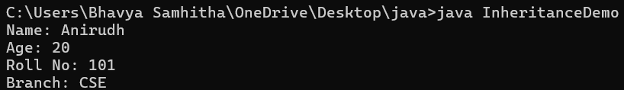

Experiment 5: Using super Keyword
Problem Statement:
Write a Java program to demonstrate the use of the super keyword for accessing superclass variables, methods, and constructors.
Requirements:
- Create a superclass Employee with appropriate variables and methods.
- Create a subclass Manager.
- Use super to access a superclass variable.
- Use super to invoke a superclass method.
- Use super() to invoke the superclass constructor.
- Display the complete employee and manager details.
// Superclass
class Employee {
String role = "Employee";

Employee() {
System.out.println("1. Superclass constructor called.");
}

void showRole() {
System.out.println("2. Superclass method called.");
}
}

// Subclass
class Manager extends Employee {
String role = "Manager";

Manager() {
super(); // 1. Access superclass constructor
}

void display() {
super.showRole(); // 2. Access superclass method
System.out.println("3. Superclass variable: " + super.role); // 3. Access superclass variable
System.out.println("4. Subclass variable: " + this.role);
}
}

// Main Class
public class SuperClassDemo {
public static void main(String[] args) {
Manager m = new Manager();
m.display();
}
}


